Ensign Ricky

CSCI 1101 Term Project, Winter 2014

Team Members: Parisa Farukh, Randy Herritt, Ye Liang, Tristan Trim

Instructor: Dr. Srini Sampalli

Objective

The objective of the project was to demonstrate a text based RPG game demonstrating object orientated programming and data structures.

Design

Design of GUI

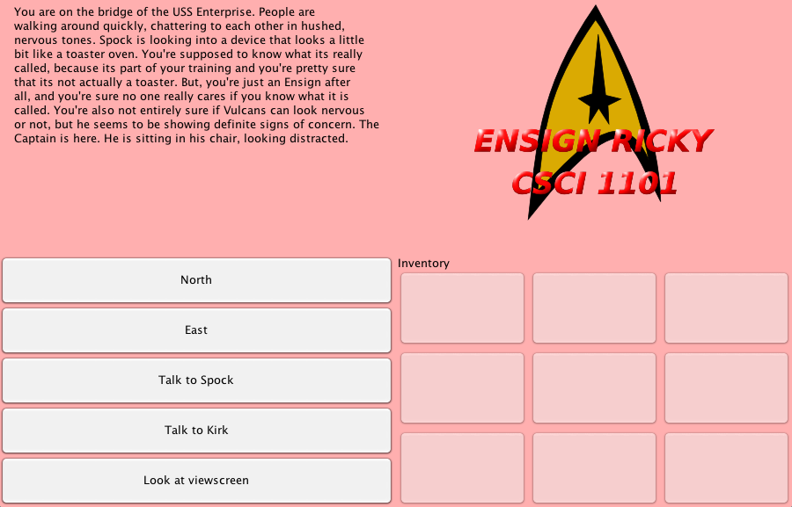
Figure 1: Demonstration of Graphic User Interface of Ensign Ricky

Design of Game Objectives

Design of Story

Design of Code

UML

Sample Code

Test Cases

Conclusion

